ANT Build with java project Example

I have taken the sample project BatchPro and the project structure following

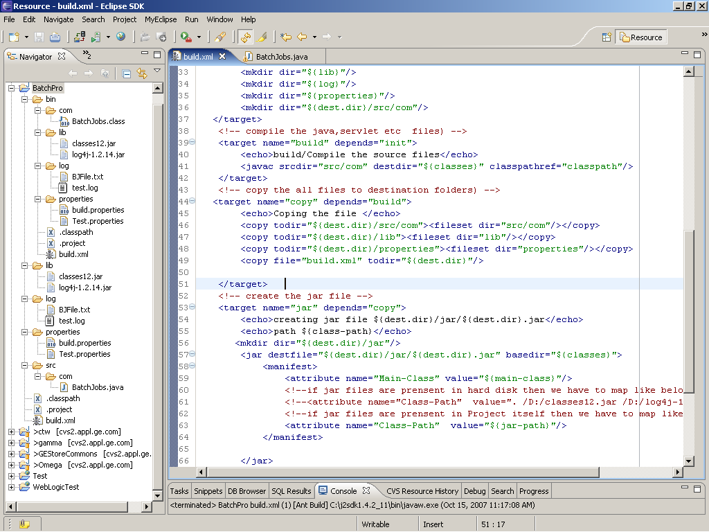

Required jar file for this java project are classes12.jar, ANT build jar and log4j.jar

Note : if want to run in cmd prompt then download and extract ANT jar file and go with bin directory and paste the build.xml to bin directory and run just like C:\ant\bin\ant

Project : BatchPro

This having following folder like bin, lib, src etc...

Bin: this is having the .class file and whatever having the project
Lib: this containing the classes12.jar and log4j-1.2.14.jar
Log: after running this project two file create and store in it.
Properties: this is having one file like Test.properties

Test.properties

#property file for storing input

username = Yogarajan
driver = Oracle Driver

src: the source folder contain the java, servlet files

BatchJobs.java

package com;
import java.io.FileInputStream;
import java.io.FileNotFoundException;
import java.io.FileOutputStream;
import java.io.IOException;
import java.io.PrintStream;
import java.sql.Connection;
import java.sql.ResultSet;
import java.sql.SQLException;
import java.sql.Statement;
import java.util.Properties;
import javax.naming.Context;
import javax.naming.InitialContext;
import javax.naming.NamingException;
import org.apache.log4j.FileAppender;
import org.apache.log4j.Logger;
import org.apache.log4j.SimpleLayout;
import oracle.jdbc.pool.OracleConnectionCacheImpl;
import oracle.jdbc.pool.OracleConnectionPoolDataSource;

class BatchJobs
{

public static void main(String arg[])
{
Context ctx;
PrintStream p;
try
{
ctx = new InitialContext();
p = new PrintStream( new FileOutputStream("D:/BJFile.txt"));
OracleConnectionPoolDataSource ods=new OracleConnectionPoolDataSource();
//or DataSource ods=new DataSource(); DataSource
ods.setDriverType("thin");
ods.setServerName("eca3t.appl.ge.com");
ods.setNetworkProtocol("tcp");
ods.setDatabaseName("ect3");
ods.setPortNumber(1521);
ods.setUser("ec2gen");
ods.setPassword("w83trss");
//following four line will not come for DataSource
OracleConnectionCacheImpl oci=new OracleConnectionCacheImpl(ods);
oci.setMaxLimit(3);
oci.setMinLimit(2);
oci.setCacheScheme(OracleConnectionCacheImpl.FIXED_
RETURN_NULL_SCHEME);
Connection con=null;
con = oci.getConnection();
Statement stmt=con.createStatement();
ResultSet set=stmt.executeQuery("select order_id from ec2.ec2_order_header where rownum<10");
while(set.next())
{
p.println (set.getString(1));

}

p.close();

p.println("Next starting getting properties value and write to txt file using File appander");
Logger logger = Logger.getLogger(BatchJobs.class);
FileAppender appender=null;
SimpleLayout layout=new SimpleLayout();
Properties prop=new Properties();
appender=new FileAppender(layout,"D:/test.log");
logger.addAppender(appender);
prop.load(new FileInputStream("D:/workspace/BatchPro/properties/
Test.properties"));
logger.debug(prop.getProperty("username"));
logger.debug(prop.getProperty("driver"));
Runtime runtime=Runtime.getRuntime();
runtime.exec("C://WINNT/system32/notepad");

}
catch (FileNotFoundException e)
{
System.out.println(e.getMessage());
}
catch (NamingException e)
{
System.out.println(e.getMessage());
}
catch (SQLException e) {
e.printStackTrace();
}
catch (IOException e)
{
e.printStackTrace();
}

}
}

Build.xml:

The build.xml file compiles and run the entire project

<?xml version="1.0" encoding="UTF-8"?>

<project name="Batch Project" default="all" basedir=".">

<property name="dest.dir" value="BatchProject"/>
<property name="src.dir" value="BatchPro"/>
<property name="classes" value="${dest.dir}/classes"/>
<property name="lib" value="${dest.dir}/lib"/>
<property name="log" value="${dest.dir}/log"/>
<property name="properties" value="${dest.dir}/properties"/>
<property name="build" value="${dest.dir}/build"/>
<property name="main-class" value="com.BatchJobs"/>
<property name="jar-path" value=". /${src.dir}/lib/classes12.jar /${src.dir}/lib/log4j-1.2.14.jar"/>
<property name="oracle-jar-path" value="./lib/classes12.jar"/>
<property name="logger-jar-path" value="./lib/log4j-1.2.14.jar"/>
<path id="classpath" >
<pathelement path="${oracle-jar-path}"/>
<pathelement path="${logger-jar-path}"/>
</path>

<target name="all" depends="clean,init,build,copy,jar,run">
</target>
<!-- Delete the Project structure-->
<target name="clean">
<echo>Cleaning ${dest.dir}</echo>
<delete dir="${dest.dir}"/>
</target>
<!-- Required directory creation-->
<target name="init" depends="clean">
<echo>Creating the required Directories</echo>
<mkdir dir="${classes}"/>
<mkdir dir="${lib}"/>
<mkdir dir="${log}"/>
<mkdir dir="${properties}"/>
<mkdir dir="${dest.dir}/src/com"/>
</target>
<!-- compile the java,servlet etc files) -->
<target name="build" depends="init">
<echo>build/Compile the source files</echo>
<javac srcdir="src/com" destdir="${classes}" classpathref="classpath"/>
</target>
<!-- copy the all files to destination folders) -->
<target name="copy" depends="build">
<echo>Coping the file </echo>
<copy todir="${dest.dir}/src/com"><fileset dir="src/com"/></copy>
<copy todir="${dest.dir}/lib"><fileset dir="lib"/></copy>
<copy todir="${dest.dir}/properties"><fileset dir="properties"/></copy>
<copy file="build.xml" todir="${dest.dir}"/>

</target>
<!-- create the jar file -->
<target name="jar" depends="copy">
<echo>creating jar file ${dest.dir}/jar/${dest.dir}.jar</echo>
<echo>path ${class-path}</echo>
<mkdir dir="${dest.dir}/jar"/>
<jar destfile="${dest.dir}/jar/${dest.dir}.jar" basedir="${classes}">
<manifest>
<attribute name="Main-Class" value="${main-class}"/>
<!--if jar files are prensent in hard disk then we have to map like below-->
<!--<attribute name="Class-Path" value=". /D:/classes12.jar /D:/log4j-1.2.14.jar"/>-->
<!--if jar files are prensent in Project itself then we have to map like below-->
<attribute name="Class-Path" value="${jar-path}"/>
</manifest>
</jar>
</target>
<!-- run the jar-->
<target name="run" depends="jar">
<echo>Running the Jar file</echo>
<java jar="${dest.dir}/jar/${dest.dir}.jar" fork="true"/>
</target>
</project>

